DAILY ONLINE ACTIVITIES SUMMARY
Date: |  | 22-05-2020
Name of the Faculty |  | MERLYN MELITA MATHIAS
No. of Students Allotted for monitoring |  |  |  |  | 19
Progress |  |  |  |  | GOOD
Whether collected report from all the allotted students |  |  |  |  | NO- (collected from 14 students. 3 students are doing internship in NARL GADANKI and they don’t have internet facility)
Online Test Summary
Subject
Semester |  |  |  | Duration
No. of students Taken |  |  |  | Passing %
Certification Course Summary
Course |  | IOT and CYBER SECURITY- an INDUSTRIAL PERSPECTIVE
Certificate Provider |  | Cambridge |  |  | Duration |  | 2hours
Coding Challenges
Problem Statement: Write a C program to merge two singly linked lists
Status: completed
Uploaded the report in Github |  |  |  |  | yes
If yes Repository name |  |  |  |  | https://github.com/Merlyn23/Coding-challenges
Uploaded the report in slack |  |  |  |  | yes

Certification course details:
IOT and CYBER SECURITY- an INDUSTRIAL PERSPECTIVE
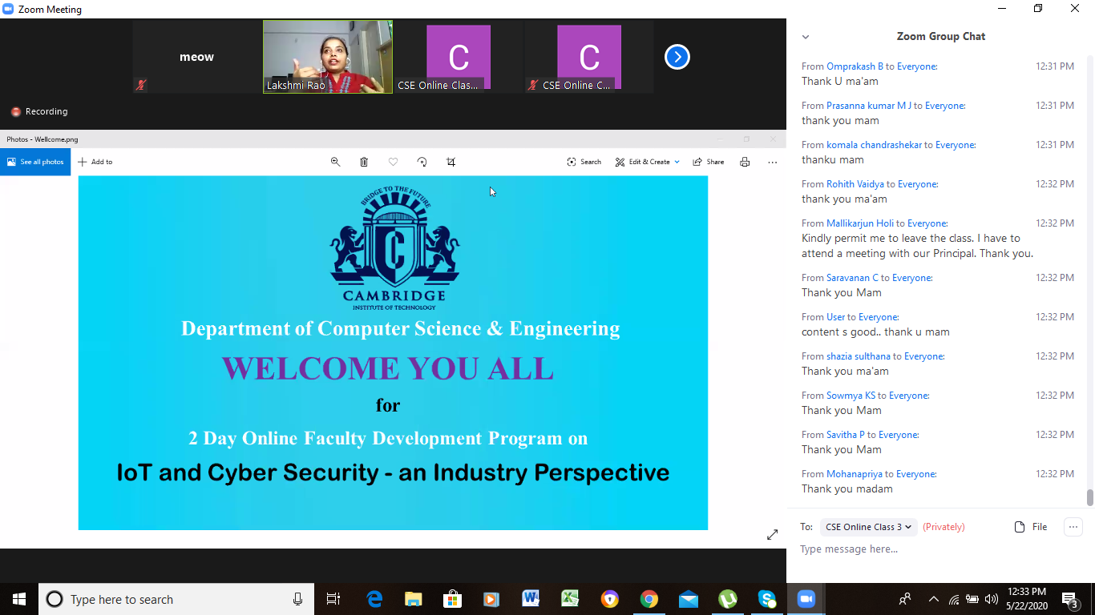

Students Report:
Kanaka BS
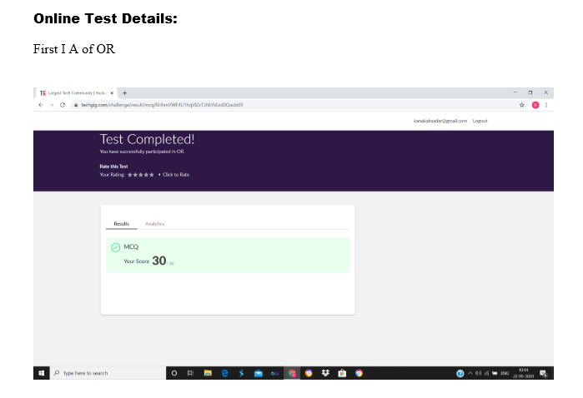
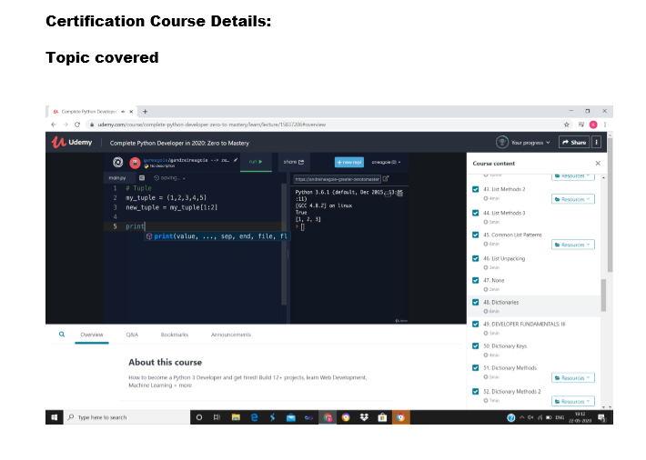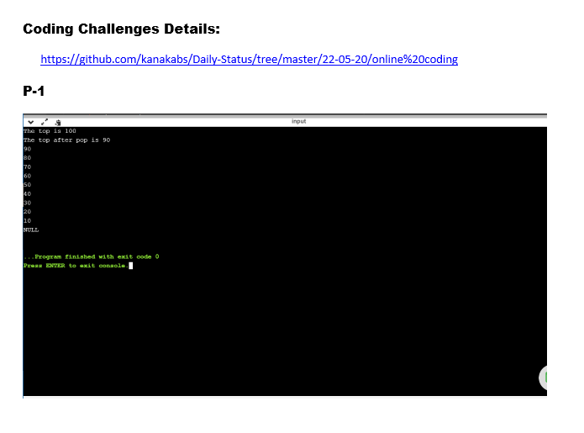
Mahek

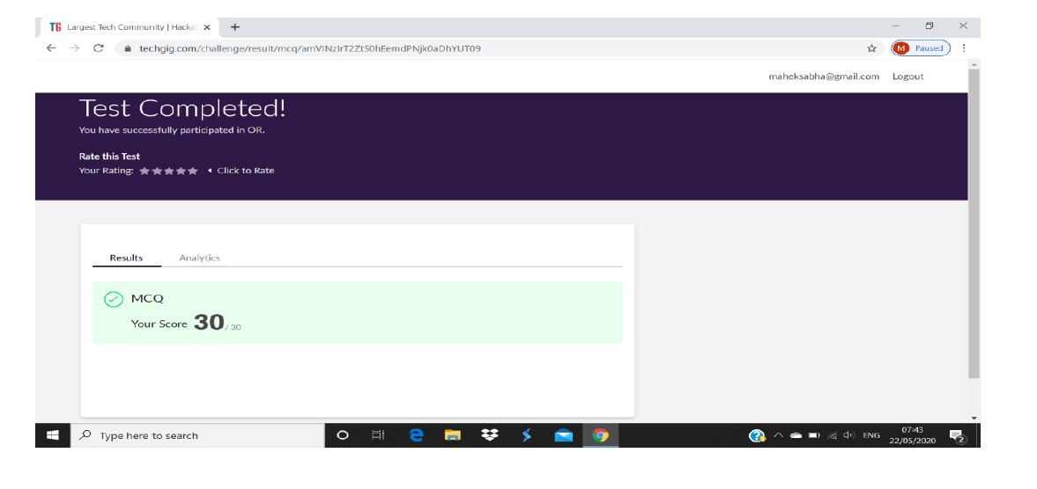
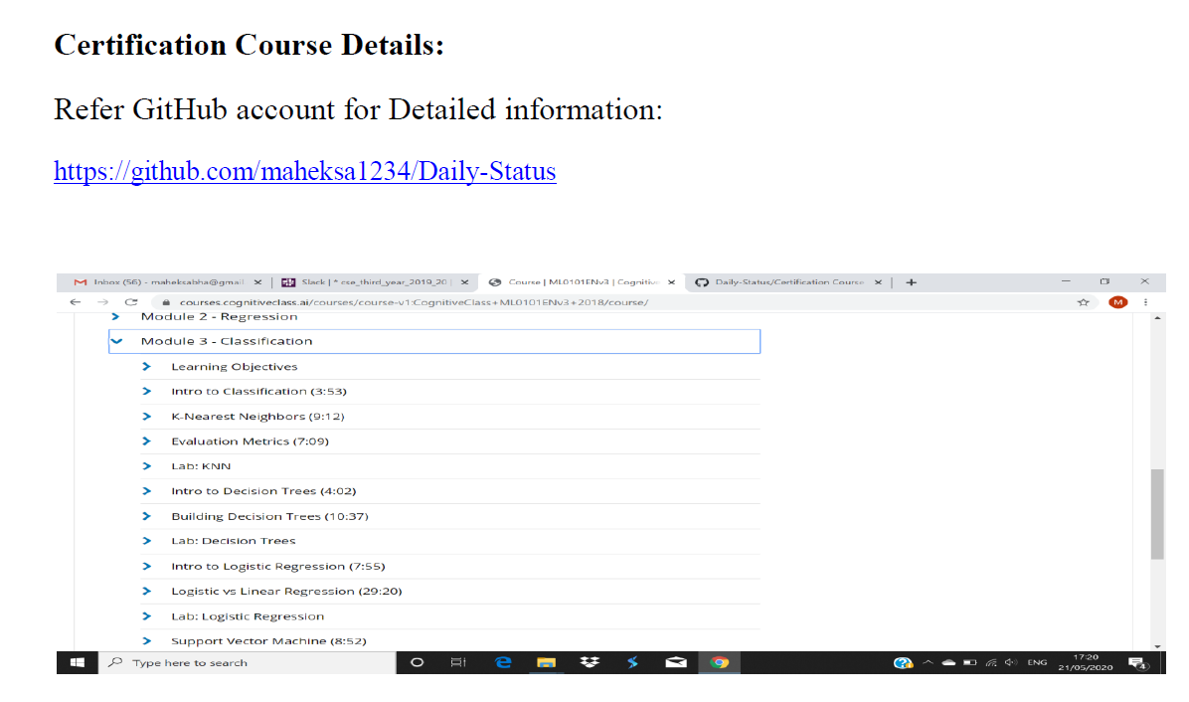
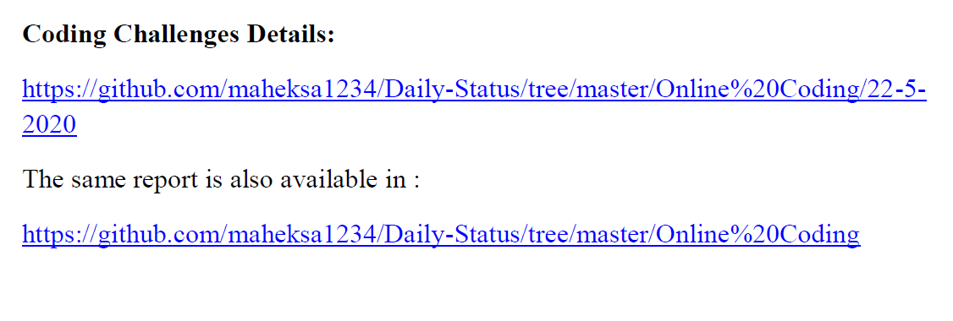

Nanditha Shetty
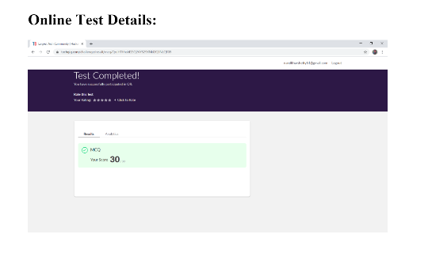
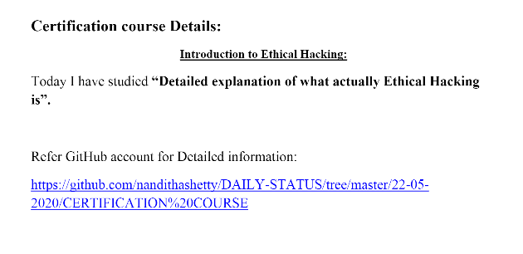
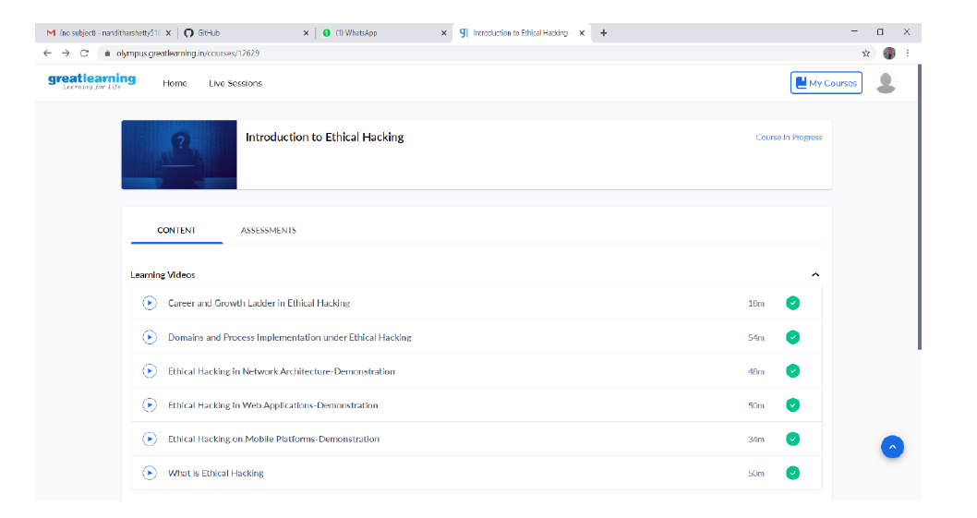
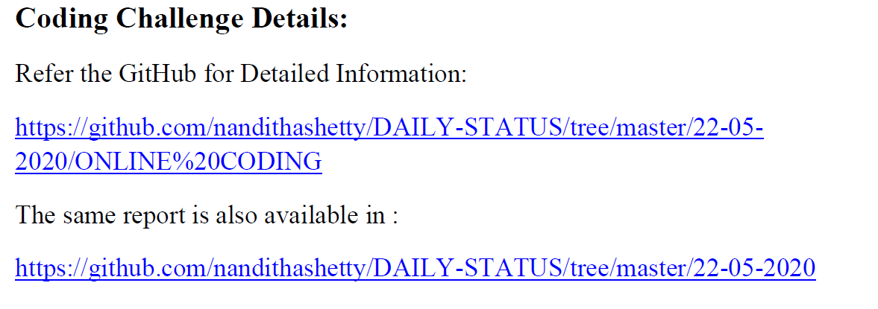

Netra SG
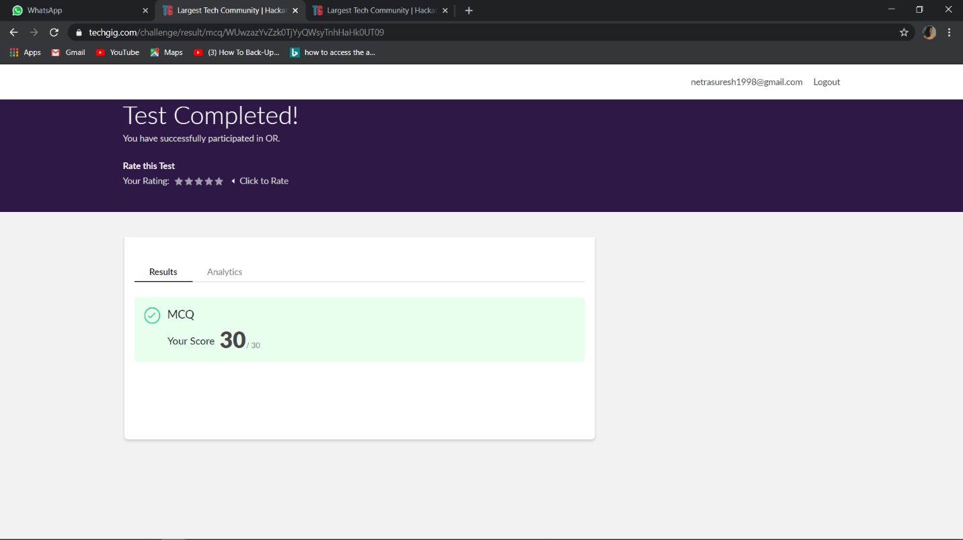
Introduction about address resolution protocols, using module in python to create ARP request. Sending and receiving packets. Blue mark in screenshot is coverd topic
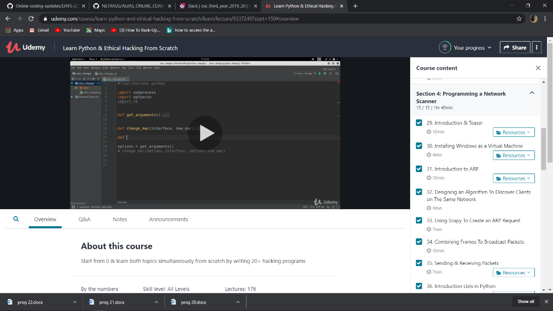

Suchithra Hegde

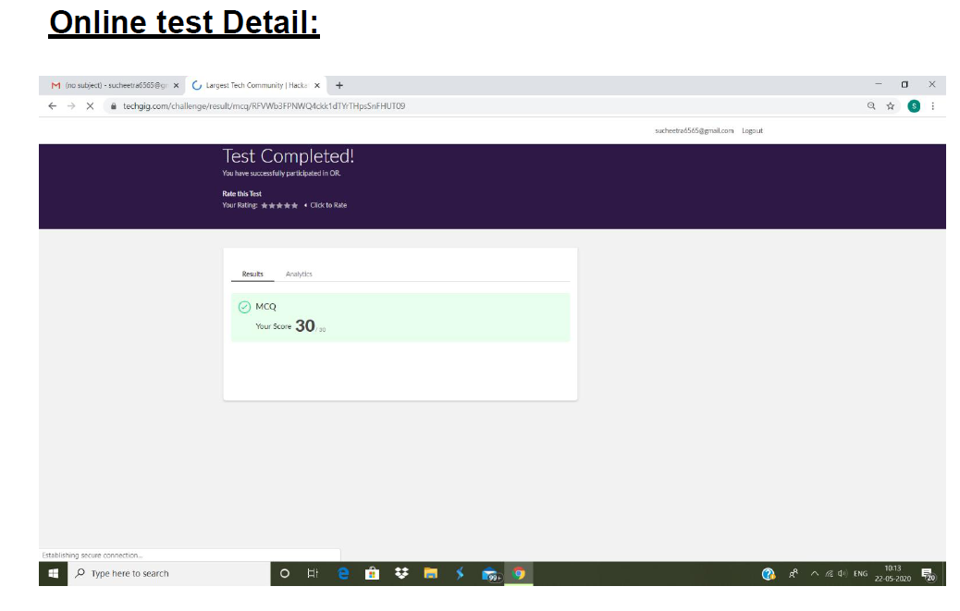
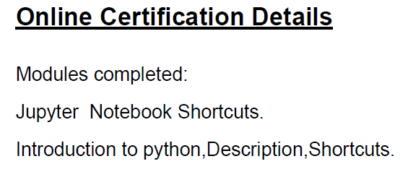
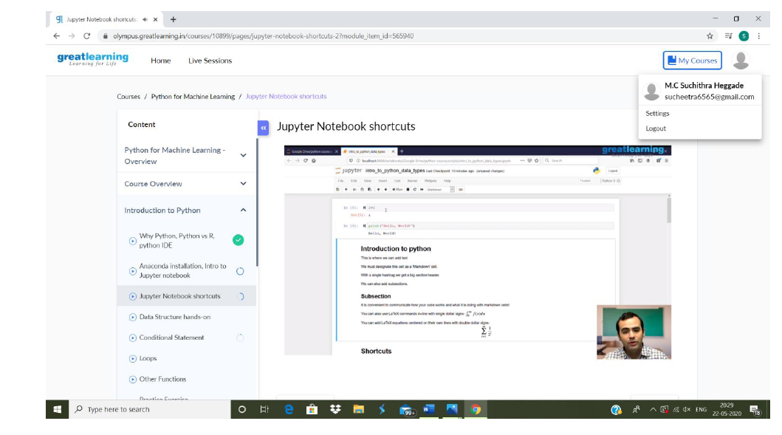
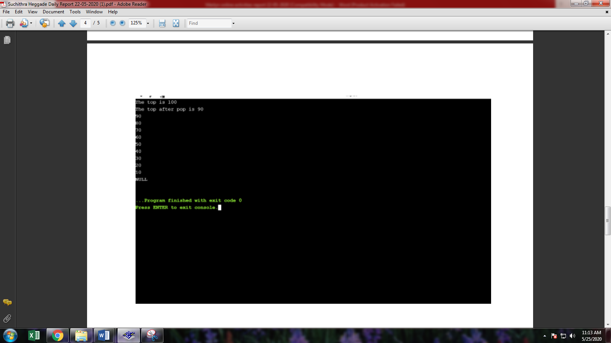

Kavya
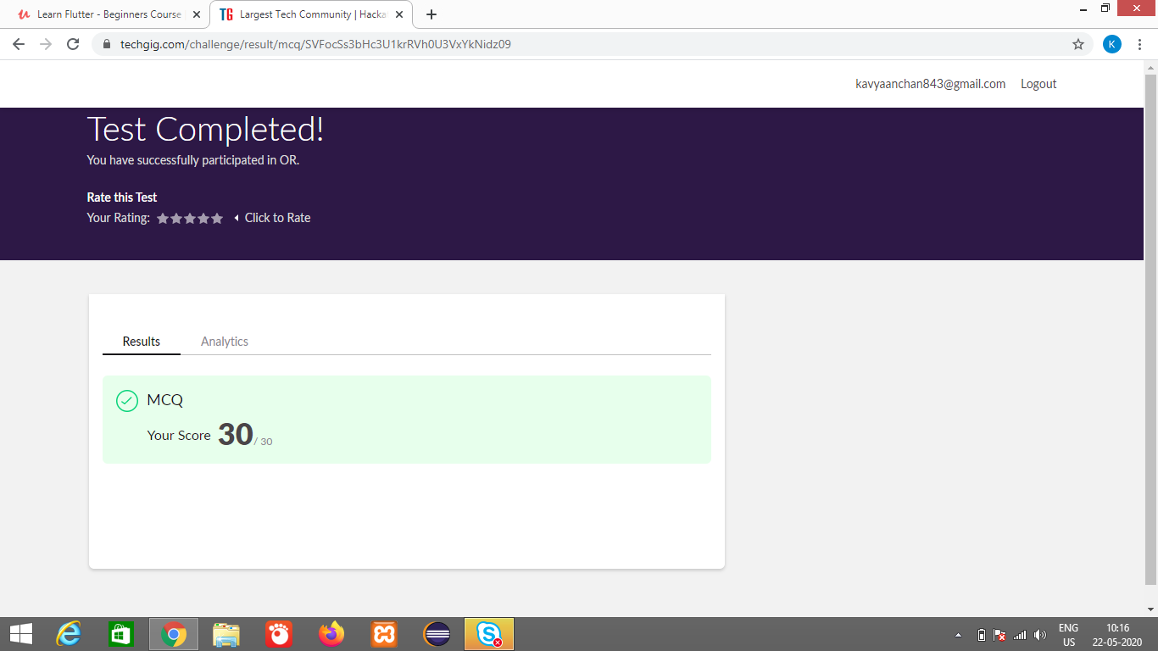
LEARN FLUTTER-BEGINNERS COURSE
This course will teach us how to create Flutter application in a very practical & simple manner, as every lecture comes with full coding screencast & corresponding code in notebook .
This course will be updates frequently as flutter and dart are in their early stages of development.

What we’ll learn
- Better understanding of flutter and it's basic widgets
- Develop basic flutter application for android and iOS

Are there any course requirements or prerequisites?
- Installed Android Studio/intellij/VSCode with flutter
- Basic knowledge of dart language
- Basic understanding of OOPS Concept

Who this course is for:
- Beginner flutter developers that are interested in developing mobile application for android and ios
- Developers that want to learn, how to create an mobile app using singlecode base.
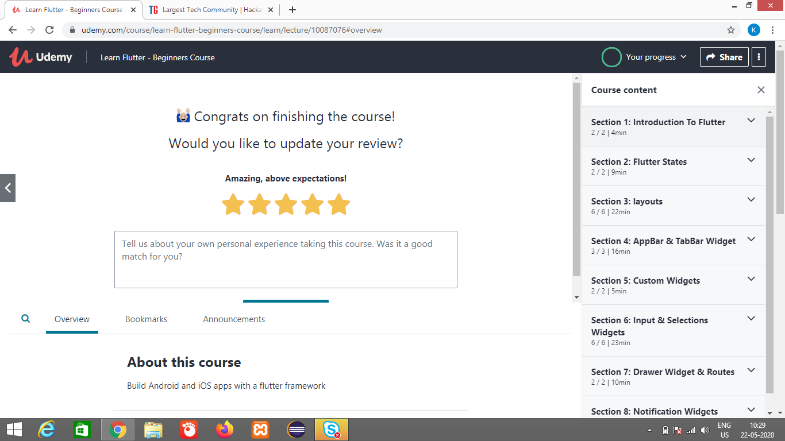
All the codes are executed in online GDE
And are uploaded in the repository https://github.com/kavya-077/DAILY-STATUS
https://github.com/alvas-education-foundation/kavya-OCA

Kavya Shetty
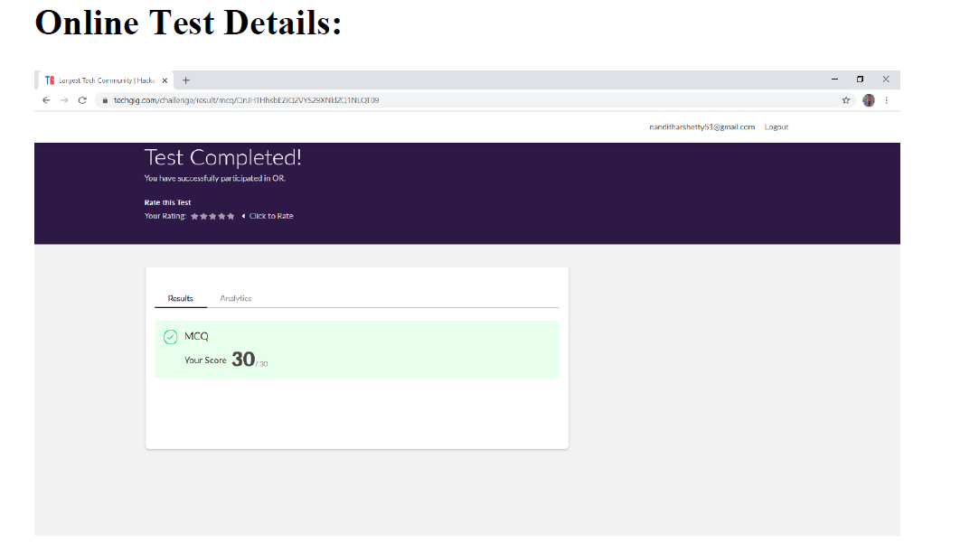
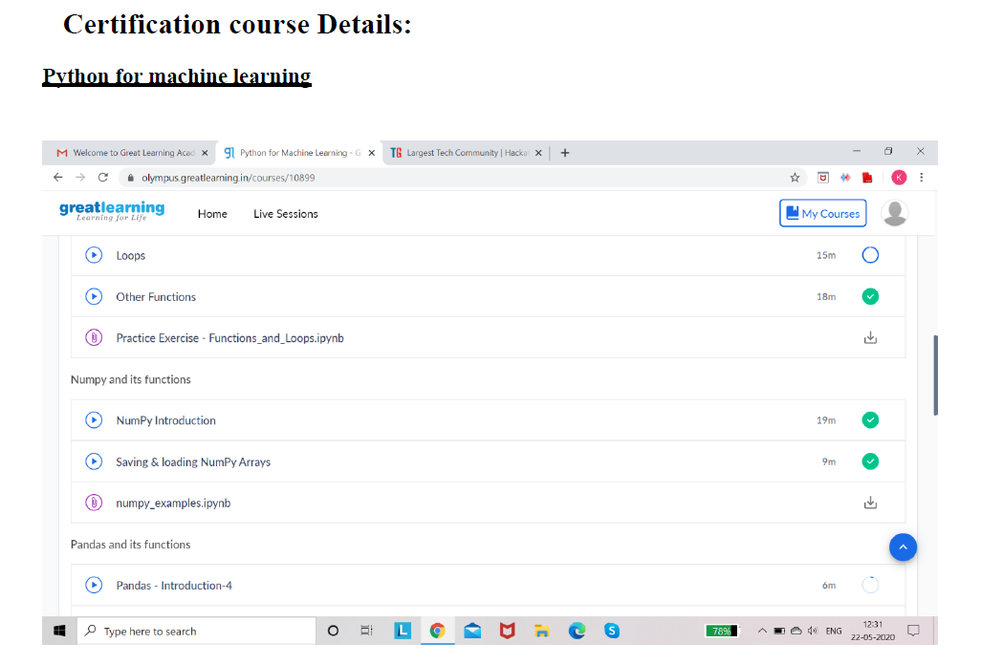
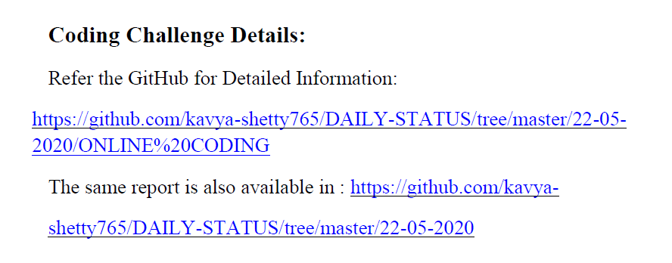

Kavana
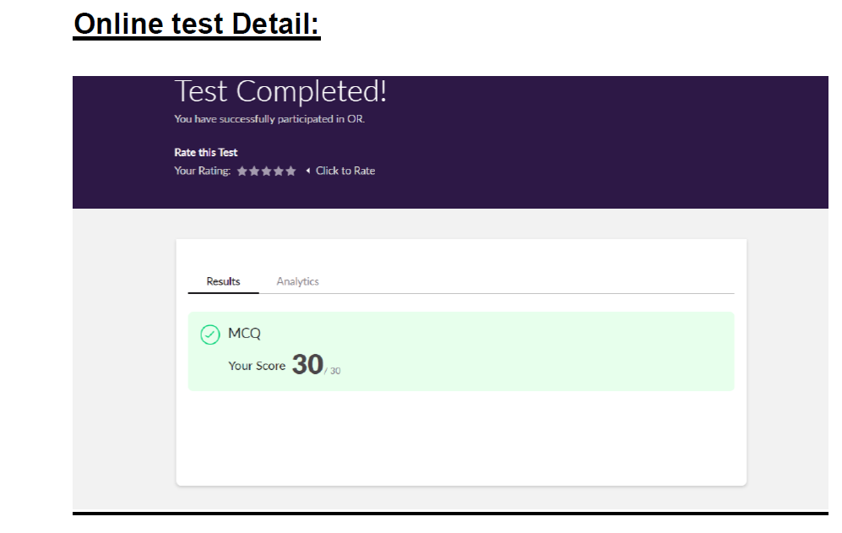
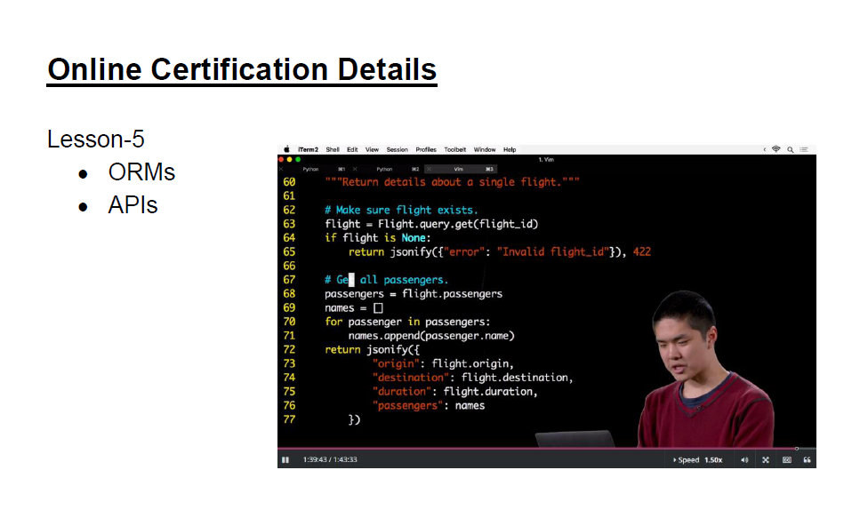
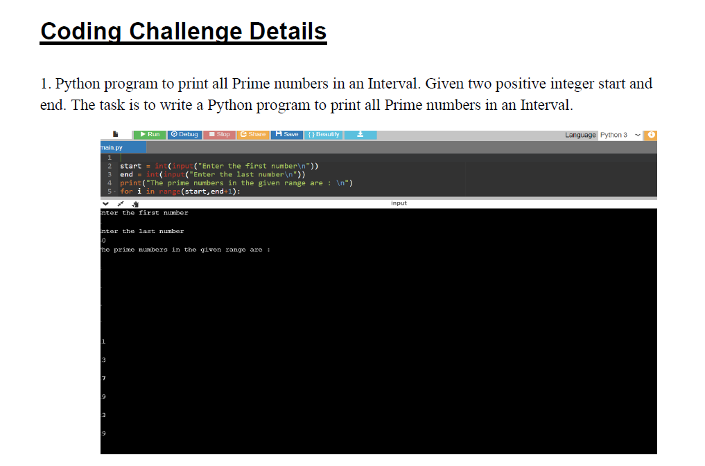

Koushik
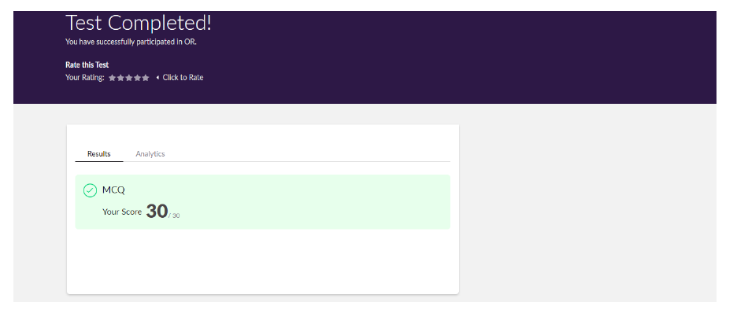

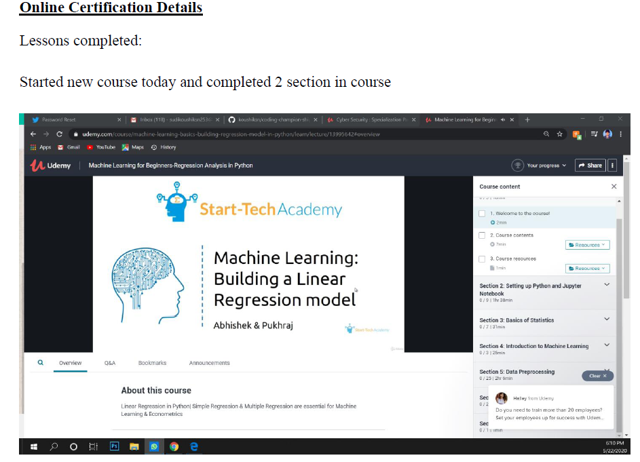
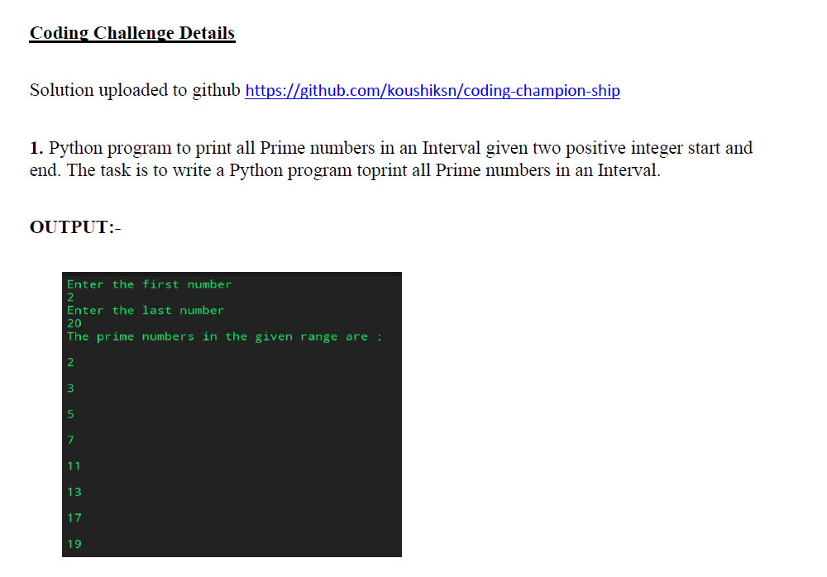

Madan G Gudigar
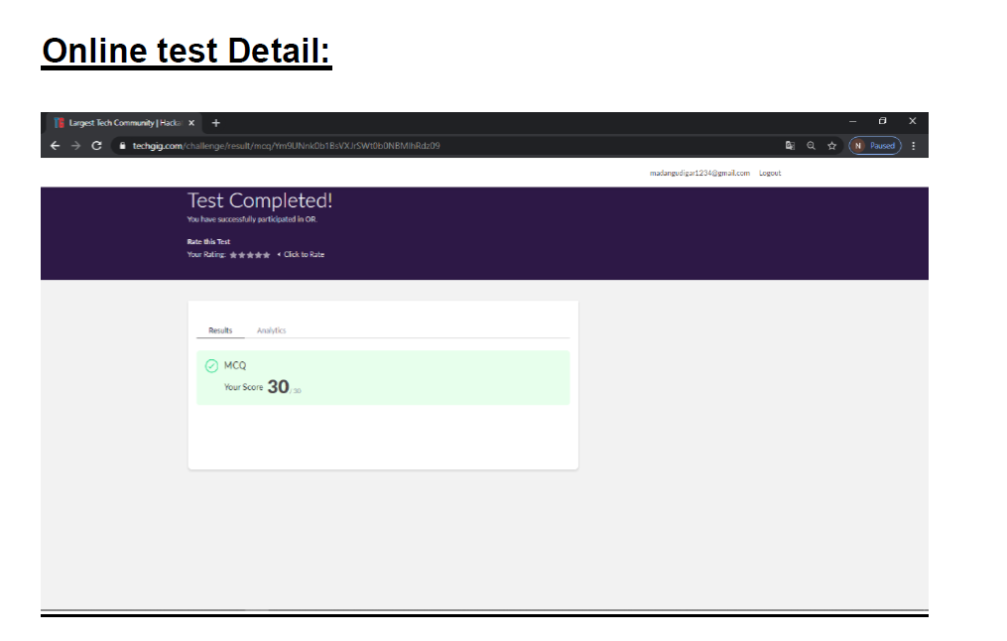
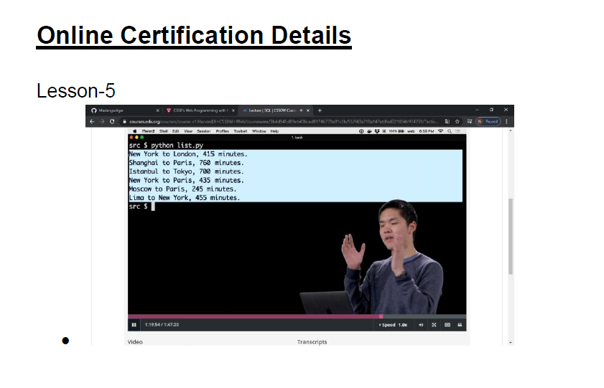
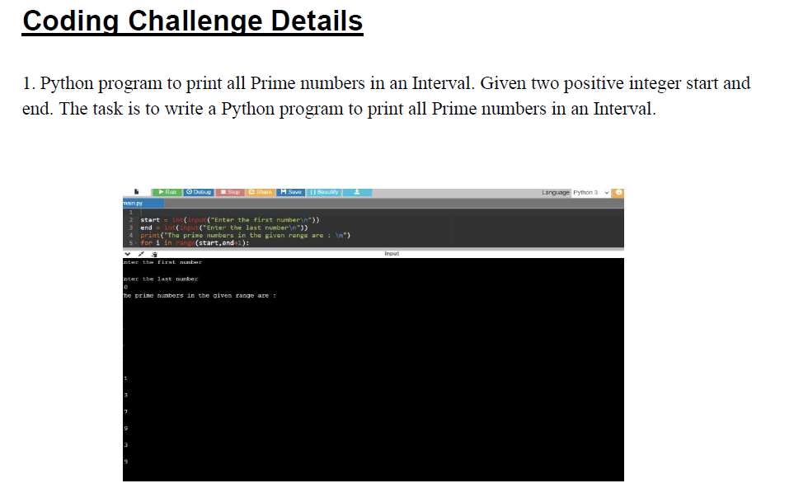
Pallavi
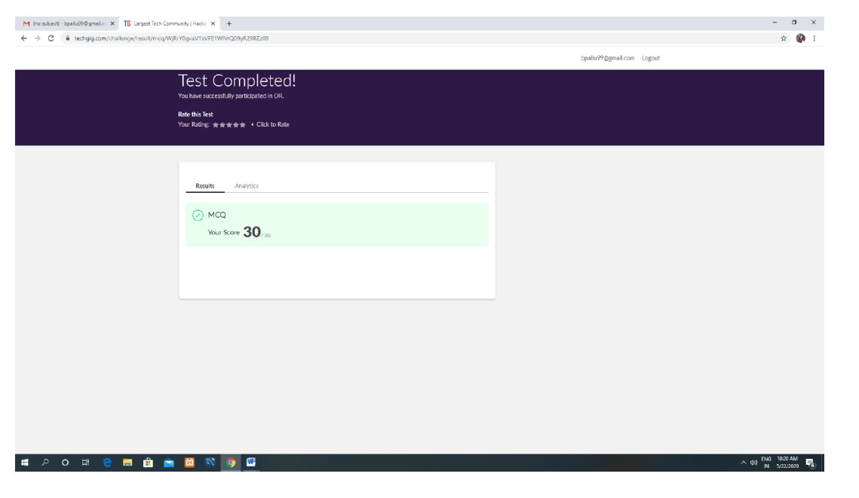
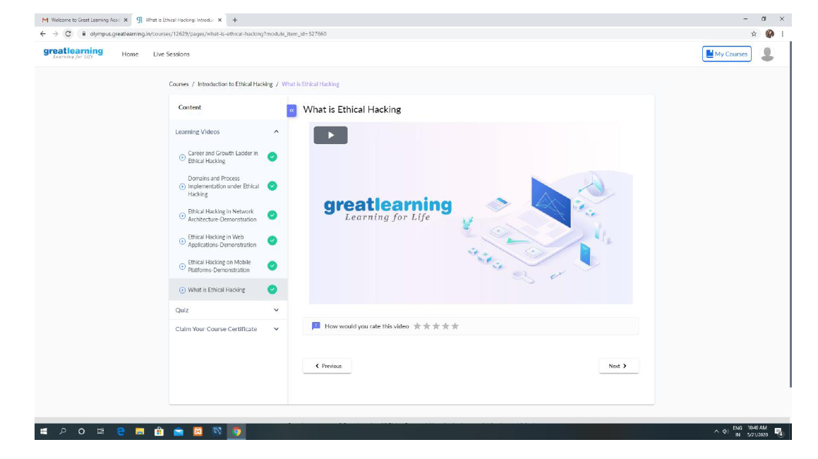

Pavana

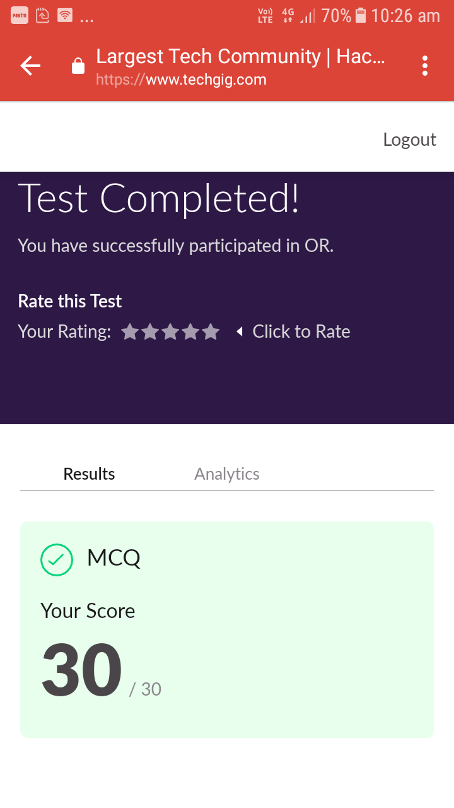

Certification Course Details:
Data Science with Open Data :
completed these topics:
1.What is Open Data and benefits of Open Data.
2.Up and Running with R, R script Instructions.
3.The Pyramid Principle.
4.Data Analysis.
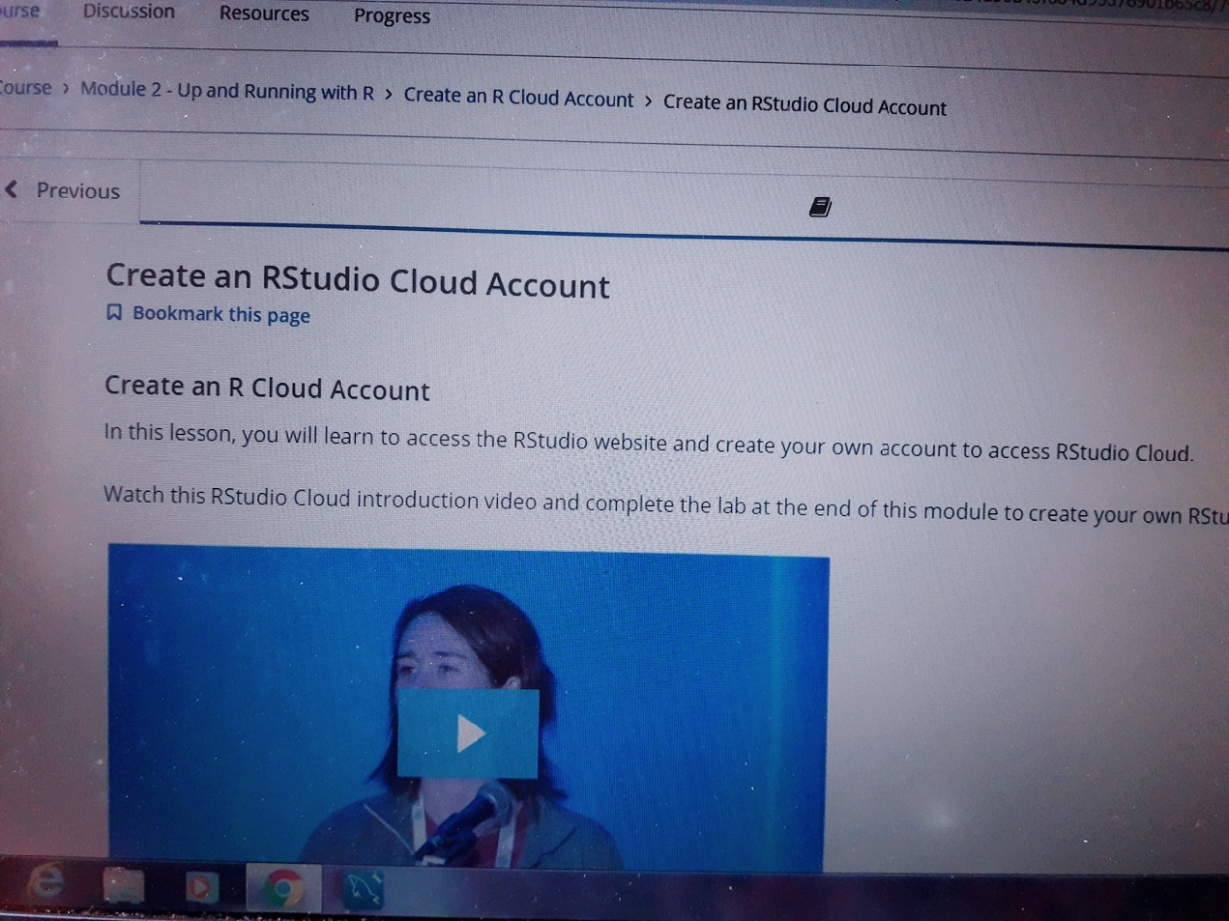
Coding Challenges Details:
https://github.com/pavana-p-kulal/DAILY-STATUS/tree/master/22-5-20/Online%20Coding

Likhitha

